Title: Weekly SQL Insights Series

Table of Contents
- Week 1: Longevity vs. Healthy Longevity (USA, 2019)
- Week 2: Longevity vs Healthy Longevity (USA 2000 v USA 2019)
- Week 3: [placeholder for next topic]
...

---

Week 1: Longevity vs. Healthy Longevity (USA, 2019)
Do you want to spend your last 14 years of life battling illness or disability? In the United States, that’s the expectation for women, with men not too far behind.
I’m excited to launch a weekly series where I’ll share SQL queries applied to real-world datasets and the insights they uncover.
While people today are living longer than in prior generations, I’m not convinced we are living healthier lives. Advances in medicine may extend lifespan, but societal changes such as more time indoors, sedentary routines, and screen-heavy lifestyles don’t always support living longer and healthier lives.
Definitions
- Lifespan = total years lived
- Healthspan = years lived in good health, measured by WHO’s Healthy Life Expectancy (HALE) metric
- Unhealthy years = the difference between lifespan and healthspan, representing years lived with illness or disability
This first analysis focused on 2019 WHO data. I chose this year because it reflects health outcomes before the COVID-19 pandemic which significantly disrupted global life expectancy trends.

My first query analyzes the gap between healthspan and lifespan in the United States for people born in the year 2019 with breakdowns between genders as well.
The below query joins life expectancy and healthy life expectancy tables, filters for the United States in the year 2019 and groups results by gender to appreciate average lifespan vs healthspan.
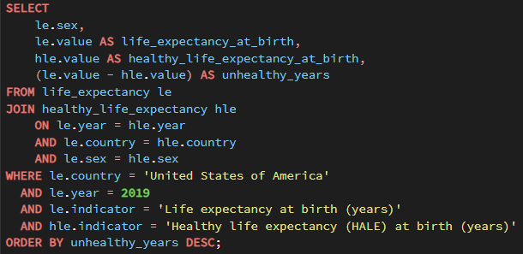
Results & Insights:
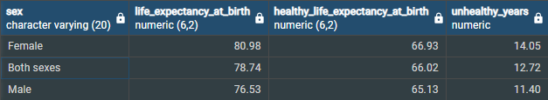
- Women have around 4 years longer of lifespan and 2 years longer of healthspan
- While women live around 4 years longer than men, 2 of those years are “unhealthy years”
- Big headline : both genders spend 10+ years of their lives in poor health.
Thanks for tuning in! That last finding is the headline to me, a statistic that raises questions about how well our society supports not just longevity but quality of life. Next week I’ll compare 2019 to the year 2000 to see how these trends have shifted over time.
Full project and dataset are in my GitHub Repo:
https://github.com/tnevar/healthy-life-expectancy-sql
#SQL #DataAnalytics #HealthcareData #Longevity #Healthspan #WHOData #QualityOfLife

---

Week 2: Longevity Trends (USA, 2000–2019)
Imagine gaining 2 extra years of life, but only half a year of health. That’s the reality for U.S. men and women when comparing the year 2019 to 2000.
This week I expanded my SQL analysis to compare U.S. life expectancy at birth in 2000 vs 2019. While both lifespan and healthspan improved over the two decades, the gap between them, widened.
Definitions :
• Lifespan = total years lived
• Healthspan = years lived in good health (WHO’s HALE metric)
• Unhealthy years = lifespan – healthspan

The below query compares U.S. life expectancy and healthy life expectancy at birth between the years 2000 and 2019. It joins the WHO datasets, filters for the United States, and groups results by gender to highlight changes in lifespan, healthspan, and the widening gap of unhealthy years over time.
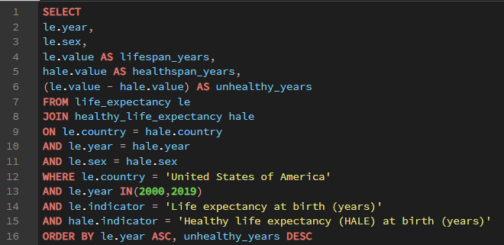
Results & Insights:
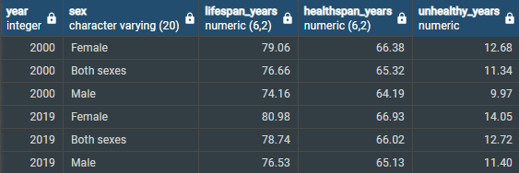
• Lifespan increased for both men and women between 2000 and 2019
• Healthspan also increased, but did not keep pace
• The gap of “unhealthy years” grew by ~1.5–2 years for each gender
Two decades of progress gave Americans barely longer lives and even there most of those added years were unhealthy ones. Women gained 0.5 healthy years but 1.5 unhealthy years; men gained nearly 1.0 healthy years and like women, nearly 1.5 unhealthy years.
While there are many factors that go into progression of longevity from a societal standpoint, indoor lighting and screen time has increased dramatically over the last 20 years. Around 2000, LED lighting began widespread adoption, and now in the United State incandescent bulbs are banned from manufacturing and sales. While energy‑efficient, some researchers and commentators are being to raise concerns about how artificial light exposure especially blue light may disrupt circadian rhythms, sleep quality, and in turn have major impacts on long‑term health. This is not something I considered before as having a major impact on progression or lack therefore of healthspan and lifespan but it is a connection that I cannot unsee now. This information was brought to my attention during a recent @AndrewHuberman podcast episode with Dr. Glen Jeffrey. More research is needed on this topic and for now serves as a useful reminder that technological progress can have unintended consequences for healthspan.
Next week I’ll shift the lens from birth to the older generation, comparing how healthspan and lifespan have changed for people turning 60 in 2000 vs 2019. Full project and dataset are in my GitHub Repo:
👉 https://github.com/tnevar/healthy-life-expectancy-sql
#SQL #DataAnalytics #HealthcareData #Longevity #Healthspan #WHOData #QualityOfLife #Trends #CircadianHealth [Repeat same structure]
📊 Week 2.5: Bringing the Data to Life (USA, 2000–2019)
Last week I shared my SQL analysis on U.S. lifespan vs. healthspan trends from 2000 to 2019. The feedback I received was incredibly helpful. Several people pointed out that while the SQL was a strong start, the insights would be even clearer with a visual.
That really resonated with me.
It was a good reminder that data analytics doesn’t end with a working query. SQL is only one part of the process. Communicating the story behind the data in a way people can instantly grasp is at least as important, potentially even more important. Without the data containing easy to make inferences, I cannot assume that people will see the trends that I can see. Visualization isn’t simply an afterthought; it’s a key part of the analysis.
So this week, I revisited the same dataset and built two simple Excel charts to highlight the core takeaways:
What the charts make clear
- Lifespan increased for both men and women
- Healthspan increased too, but much more slowly
- The gap — “unhealthy years” — widened by roughly 1.5–2 years
For reference:
lifespan = total years lived
healthspan = years lived in good health (WHO HALE)
This experience also pushed me to start learning Tableau so I can present future insights more effectively. Until then, Excel is helping me bridge the gap and even a simple chart can completely change how a dataset is understood.
And while this week focused on visualization, next week I’ll return to a new SQL query.
This step back reminded me that visualization is just as much a part of the analytical process as querying. I’m excited to build on it with the next dataset while creating a complete comprehensive analytical process
🔗 Full SQL project & dataset:
https://github.com/tnevar/healthy-life-expectancy-sql
Next week, I’ll shift the lens from birth to older adults, comparing healthspan and lifespan for people turning 60 in 2000 vs 2019.
#SQL #DataAnalytics #Visualization #Healthspan #Longevity #WHOData #TableauJourney #QualityOfLife #CircadianHealth #AnalyticsCommunication
Week 3
📊 Week 3: Longevity After 60 — Are We Adding Healthy Years or Just More Years? (USA, 2000–2019)
Even the healthiest Americans, the ones who make it to 60, are now spending more of their remaining life in poor health.
This week I shifted my SQL analysis from life expectancy at birth to a different question:
How much life do Americans have left once they reach age 60 and more importantly how much of it is healthy?
People who make it to 60 are already a well accomplished and established group. They’ve survived early‑life risks, chronic disease, and socioeconomic disparities. In theory, this should mean healthier aging and more years of good health.
But the data tells a more nuanced story.

Definitions
• Remaining lifespan at 60 = years lived after age 60
• Remaining healthspan at 60 = healthy years lived after age 60 (WHO HALE)
• Unhealthy years = lifespan – healthspan
This week’s query joins WHO datasets, filters for the United States, and groups results by gender to highlight how remaining lifespan, remaining healthy lifespan, and unhealthy years have changed from 2000 to 2019.
Screenshot 1 📷 – SQL Query in PgAdmin 4
Screenshot 2, 3, and 4 📷 – Query Results and Charts

📈 Results & Insights
Women gained ~1.8 more years of life but only ~0.8 of those years were healthy.
Unhealthy years increased by nearly a full year.
Men gained ~2.2 more years of life with only ~1.1 healthy years.
Unhealthy years increased by more than a full year.

🧩 Why Unhealthy Years Shrink After Age 60
One thing that stood out this week was how much smaller the unhealthy period is for people who reach age 60 compared to the unhealthy years projected at birth.
For example:
• Women born in 2019 are projected to spend ~14 unhealthy years
• Women who reach age 60 in 2019 face half of that, ~7 unhealthy years ahead
This isn’t a disagreement in assumptions, it’s the survivor effect in action.
People who reach 60 are already the healthiest subset of their generation. They’ve avoided early‑life mortality, managed chronic conditions, and benefited from better healthcare access. By the time a cohort reaches 60, the individuals with the highest disease burden are no longer part of the dataset.
So this remaining group naturally has a higher healthy life expectancy, fewer unhealthy years, and later onset of disability. Even with this advantage, unhealthy years are still rising and that’s the part that deserves attention.

🧠 Key Takeaways
• People who reach 60 are living longer but not proportionally healthier.
Healthy life expectancy is improving, but slowly.
• The “unhealthy years” gap continues to widen.
Even among the healthiest survivors, late‑life morbidity is increasing.
• Longevity gains are increasingly “health‑light.”
We’re adding years faster than we’re adding good years.
• The survivor effect masks but doesn’t erase the trend.
Even the healthiest older adults are spending more years in poor health than they did two decades ago.

🛠️ Next Week
I’ll continue expanding this SQL project by looking at year-over-year changes from 2000 to 2019 in the U.S. I’m curious whether any patterns in the data align with broader societal or medical shifts during that period. One area I’m especially interested in exploring further is the rise and widespread adoption of LED lighting, something I mentioned last week, and how changes in light exposure intersect with long-term health trends. At this point I feel confident in saying that greater light exposure causes a long-term negative effect, the bigger questions is by how much, and at what point will the effects be seen. More to come as I dig deeper into the data.
Full SQL project & dataset:
👉 https://github.com/tnevar/healthy-life-expectancy-sql
#SQL #DataAnalytics #HealthcareData #Longevity #Healthspan #WHOData #QualityOfLife #AgingTrends #AnalyticsCommunication
Week 4
📊 Week 3: Longevity After 60 — What happened after 2010? (USA, 2000–2019)
For all the innovation of the last 15 years, the one thing we haven’t improved is the part that matters the most: the years we are actually healthy.
Everyone talks about the progress we’ve made in aging, but the truth is that nearly all the gains of the 21st century happened before 2010. Since then, we’ve added barely any life and we’ve even taken away from health.
This week, I shifted my SQL analysis to focus on life expectancy at age 60 to find out my answer to this question and to have it backed by data:
Has there truly been stagnation in lifespan and healthspan for older Americans over the last 15 years?
The data makes it clear: not only have we stagnated in lifespan, but we’ve actually lost healthy years for older Americans since the early 2010s. It’s mind-blowing that despite extraordinary technological and scientific breakthroughs, we’re enjoying fewer meaningful years than we were 15 years ago.
Over the past decade and a half, we’ve seen AI-driven smartphones, CRISPR gene editing, reusable rockets, quantum processors, global satellite internet, and autonomous vehicles become reality. Drones, automation, and robotics have reshaped entire industries. Yet even with all this progress, the extra years we’ve gained often come with more chronic illness and not better health. We’re living longer, but not necessarily living better, and that disconnect is hard to ignore.
Definitions
- Remaining lifespan at 60 = years lived after age 60
- Remaining healthspan at 60 = healthy years lived after age 60 (WHO HALE)
- Unhealthy years = lifespan – healthspan
This week’s query joins WHO datasets, filters for the United States, and groups results by gender to show how remaining lifespan, remaining healthy lifespan, and unhealthy years have changed from 2000–2019.
Screenshots:
📷 Male and Female Lifespan Charts
📷 SQL Query in PgAdmin 4
📈 Results & Insights
The data confirms it: healthspan peaked for Americans in the early 2010s. Since then, older adults have spent more of their remaining years managing disability or chronic disease. 99% of the improvement in healthy years for American men since 2000 occurred between 2000 and 2010. For women the data shows an even more harrowing note, there has been a backtracking of healthy years since 2010.
🧩 Why Americans Haven’t Added Healthy Years Since the Early 2010s
This question has been stuck in my head: How can we not be living any healthier with all the innovation of the last 15 years?
The short answer is that most medical progress has focused on managing chronic conditions, not preventing them. Chronic diseases like obesity and diabetes which have been in “crisis” mode since the 1990s continue to rise, and we haven’t meaningfully reduced their incidence.
At the same time, technology has connected the world while amplifying comparison and stress. Social media highlight reels distort reality, making people feel like they’re falling short.
Since 2010, we’ve added years but not quality. Chronic illness, stress, burnout, and mental-health struggles have all increased. The cost of living has outpaced wages, leaving people feeling less secure. Social connection has weakened, ultra-processed diets and sedentary lifestyles have become more common, and institutions like healthcare, education, and work haven’t adapted to modern pressures.
The result is a world full of innovation but surprisingly little improvement in how healthy, supported, or fulfilled people actually feel.
🌱 Signs of Change
There are encouraging shifts. People are beginning to use technology not just for convenience, but for well-being. Wearables provide insight into long-term trends and help build awareness. Companies like Function Health give individuals early data before issues become chronic. And social media is increasingly being used to build community rather than fuel comparison.
🧠 Key Takeaways
• Most improvements in healthspan for Americans over 60 happened before 2010
• Recent technological advancements have focused on convenience, not lifestyle or prevention
• Chronic diseases that surged in the 1990s are now fully impacting older adults
• Weaker social connections reduce purpose and resilience as people age
🛠️ Next Week
I’ll expand this SQL project by comparing the U.S. to other countries around the globe. We often hear that peer nations are healthier — but is that difference driven by older adults, and how large is the gap? More to come as I dig deeper into the data.
Full SQL project & dataset:
👉 https://github.com/tnevar/healthy-life-expectancy-sql
#SQL #DataAnalytics #HealthcareData #Longevity #Healthspan #WHOData #QualityOfLife #AgingTrends #AnalyticsCommunication

